
The School District of Osceola County, Florida

Professional and Technical High School

501 Simpson Road  Kissimmee  Florida 34744
Phone: 407-518-5407  Fax: 407-344-2467  www.path.osceolaschools.net

Principal
Kelly Roman

Assistant Principal
Demetrik Harris

SCHOOL BOARD MEMBERS
Teresa “Terry” Castillo
Vice Chair
District 1 – Kissimmee
407-577-5022

Bethzaida Garcia
District 2 – Kissimmee
689-318-7667

Anthony Cook
District No. 3 – Kissimmee
689-318-7690

Heather Kahoun
Chair
District No. 4 – Kissimmee
689-241-7822

Paula Bronson
District No. 5 – St. Cloud
689-318-7674

Superintendent
Dr. Mark Shanoff

Mission Statement
The mission of Osceola Technical College and the Professional and Technical High School is to provide education, which prepares and inspires all to their highest career and academic potential by integrating technical and academic training.

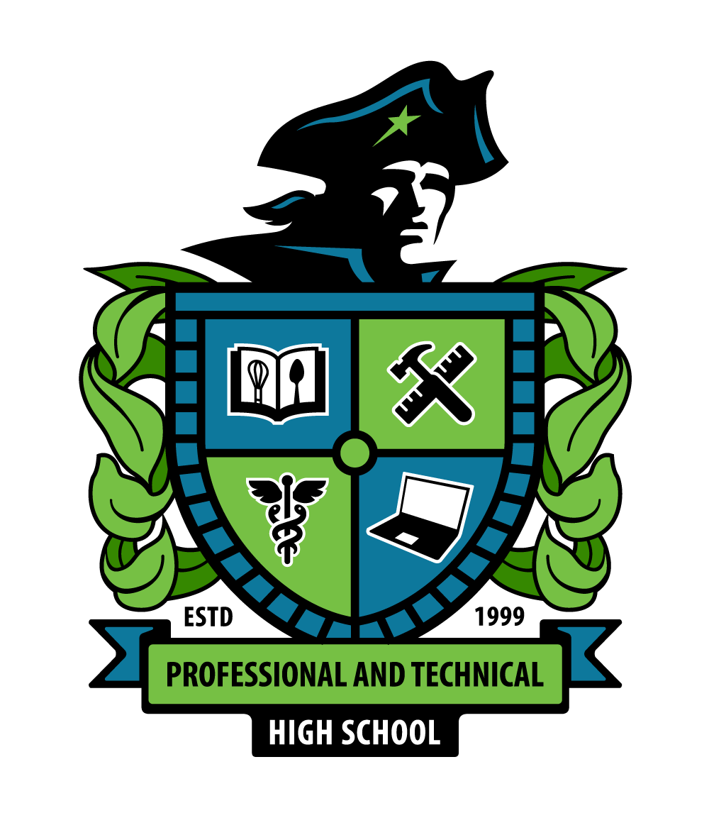

Parents and Students,

As state testing approaches, I wanted to take a moment to review testing policies regarding the importance of state testing and of testing security. State exams and End-of-Course exams are very important for all students, and have a direct effect on student grades, promotion, class placement, and graduation. Students and teachers have been working very hard the whole year to prepare and gain the knowledge and skills they need to be successful in class and on state exams.

With that in mind, test security is our number one priority for all students. Cheating or suspected cheating of any kind will not be tolerated and can lead to serious consequences for students. As a reminder, students are NOT ALLOWED to have or use ANY technology during testing. Technology should be left at home, in a locker, or in a backpack for ALL testing. Even if the technology is turned off, and even if the student does not use the technology, if it is on their person anytime during a test, their test will be immediately invalidated, no questions asked.
The state script specifically says “You may not have any electronic or recording devices, other than the device you are using to take the test, at your desk, in your pockets, or anywhere you can reach them at any time during this test, even if they are turned off or you do not use them. Electronic and recording devices include but are not limited to cell phones, smart glasses, tablets not used for testing, smartwatches, cameras, and any device capable of listening, recording, storing, viewing, or playing back audio or visual content. You may not use Bluetooth/wireless headphones/earbuds during testing. If you have access to or use any electronic or recording devices at any time during this test, including breaks, your test will not be scored. Check your pockets and your work area now to make sure you don’t have any electronic devices. If you have any devices with you right now, please turn them off and raise your hand.”
Technology aside, students are not to talk, signal, or interact with any other students at any time during testing. This behavior will be considered cheating, and students will be removed from the testing location and their test will be invalidated. Students should remain 100% focused on their own exam during their allotted testing period, behaving as if no other students are in the room. Interruptions in a testing room can have effects on all students, not just those students who are not following the rules, and these types of distractions are unfair to those students and teachers who have been working hard all year.

Our students at PATHS are the best in the Osceola County School District, and we want them to show what they have learned this year and do their absolute best on all state testing without distraction. Many state test scores will be immediately available and we at PATHS want our students to be successful so they can continue on the right track toward graduation. If you have any questions or concerns, feel free to reach out anytime.

Dr. Ryan Chase
Testing Coordinator
Professional and Technical High School
Ryan.Chase@osceolaschools.net

